Tournament: |  | Date:
Opponent: B / W  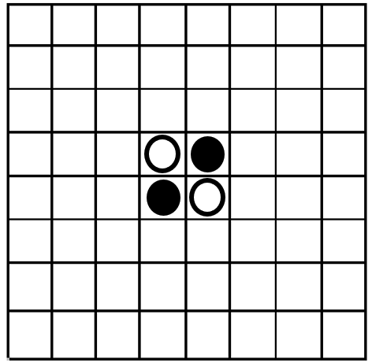  Score: / | Opponent: B / W  Score: / |  | Opponent: B / W  Score: /
Opponent: B / W  Score: / | Opponent: B / W  Score: / |  | Opponent: B / W  Score: /
Opponent: B / W  Score: / | Opponent: B / W  Score: / |  | Opponent: B / W  Score: /
Tournament: |  | Date:
Opponent: B / W  Score: / | Opponent: B / W  Score: / |  | Opponent: B / W  Score: /
Opponent: B / W  Score: / | Opponent: B / W  Score: / |  | Opponent: B / W  Score: /
Opponent: B / W  Score: / | Opponent: B / W  Score: / |  | Opponent: B / W  Score: /

